**Genetics**

**Content**

Inheritance and Pedigrees

* dominant, recessive, co-dominant, autosomal and sex linked inheritance
* sex determination
* monohybrid crosses using punnet squares and simple probabilities.
* construction and interpretation of pedigrees for autosomal and sex-linked conditions
* probabilities of producing affected offspring for autosomal and sex linked inheritance
* inheritance of mitochondrial DNA.

Variation and Mutation

* function and significance of chromosome changes in meiosis
* compare mitosis and meiosis.
* crossing over, random assortment, non-disjunction.
* random fertilisation.
* causes of mutations / changes in the DNA sequence
* conditions caused by mutations including somatic (*e.g. cancer)* and germ line (*e.g. PKU)*
* chromosomal mutations including the analysis of karyotypes.
* new variations due to mutations may be advantageous or disadvantageous to survival
* differential survival of genotypes/phenotypes (e.g. lethal recessives)

Individual differences:

* genetic disorders linked to particular populations (*e.g. Tay-Sachs, sickle cell anaemia and thalassemia).*
* Genetic testing of parents and offspring for gene and chromosomal abnormalities.
* treatment for various genetic diseases.

Human Genome Project:

* information provided by the Human Genome Project
* range of possible uses for this information.

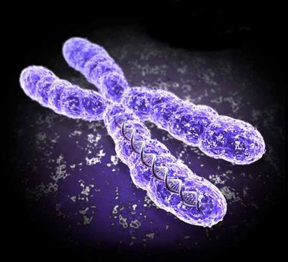

**Questions from Text**

Chapter 18

Review Questions: 1-11

Apply Your Knowledge: 8-13

Chapter 19

Review Questions: 1-9

Apply Your Knowledge: 1-4 & 6

Chapter 20 Chapter 21

Review Questions: 1-7 Review Questions: 1-10

Apply Your Knowledge: 1-8 Apply Your Knowledge: 1-8